
Kingdom of Saudi Arabia

University of Tabuk

College of Engineering

Industrial Engineering Department
المملكة العربية السعودية

جامعة تبوك

كلية الهندسة

قسم الهندسة الصناعية

Parking at University of Tabuk, Saudi Arabia, Problems and Solutions.
Winter 2024

Eng. Saad Ali

Supervisor: Dr. Abdullah Alghuried

Acknowledgment

It has been a wonderful & intellectually stimulating experience working on “Parking at University of Tabuk, Saudi Arabia, Problems and Solutions.” which gives us the full knowledge & innovative ideas in the field of Campus Transportation and Parking Lot Design.

I would like to extend our deepest gratitude to our supervisor, Dr. Abdullah Alghuried, for his continuous guidance, valuable insights, and support throughout this project. His expertise and encouragement have been instrumental in the successful completion of this work.
I am also deeply grateful to Tabuk University and the Department of Industrial Engineering for providing us with the resources and opportunities necessary to pursue this research.

Abstract
This project has applied various concepts related to identifying, assessing, and reducing traffic congestion by organizing parking within the university campus. The aim is to enhance academic performance, safety, environmental impact, accessibility, operational efficiency, and overall satisfaction. By integrating these approaches with data analysis tools, the project seeks to develop more organized and sustainable methods for improving the appearance and functionality of parking areas.
This study serves as a strategic framework, based on collected data, to evaluate the level of congestion and visual distortion in the parking areas of Tabuk University. Consequently, the research provides actionable insights for the university to focus on assessing visual distortion and errors in parking layouts while implementing industrial engineering tools to create well-organized and aesthetically pleasing parking facilities.

Table of Contents

CONTENTS
Page no.
Abstract i
List of Figures ii
List of Tables iii
List of Symbols iiii
Chapters
1. Introduction
1.1 General 1
1.2 Problem Statement 1
1.2,1 Visual distortion 2
1.2.2 The 8:00 AM Congestion 2
1.2.3 Staff and Faculty Members 2
1.3 Objectives 3
2. Literature Review 4
2.1 Definition of traffic congestion 4
2.2 Parking Search Caused Congestion 4
2.3 Previous Solutions and Studies 5
2.4 Study of Parking Problem on University Campus 5
2.5 Parking fees 5
2.6 Sustainability 6
2.7 Tree Planting 6
3. Methodology 7-8-9
4. Data analysis and results 9-10-11-12-13
5. Recommendations 14
6. Conclusion 14

KEYWORDS: Tabuk University, Traffic Congestion, Campus, Data Analysis, Parking.

Table of Figures

CONTENTS
Page no.
1. Figures 1. Some pictures contains visual distortion. 2
2. Figures 2. Wrong Parking in the staff and faculty members areas. 3
3. Figures 3. University map. 8
4. Figures 4. Parking Capacity. 8
5. Figures 5. Number of cars expected. 9
6. Figures 6. The code and the results in R. 9
7. Figures 7. Results of our students parking analysis. 10
8. Figures 8. The code used for the T-TEST. 11
9. Figures 9. Results of The T-TEST analysis. 12
10. Figures 10. Final analysis for The students parking zones. 12
11. Figures 11. Results of our Faculty members and staff parking analysis. 13
12.Figures 12. Parking capacity (Staff). 13
13. Figures 13. Surplus of parking capacity in the staff parking. 13

1. Introduction
1.1 General
The term "Traffic Congestion" means a situation in which there are a large number of vehicles moving slowly [1]. It is also said that “congestion is the situation where the introduction of an additional vehicle into a traffic flow increases the journey times of the others” (Thomson and Bull, 2001). The term university campus refers to an institutional space that is designed for use in the education and residence of college students [2], and includes the building and other physical elements found in the associated area [3] also [4] describes the university as a small city because they commonly have their own communities. It's important to look for a solution for our university because the problem has been going on for a long time and a problem like this may have a great impact on different aspects of the life of everyone on the university campus. Through this research, we aim to find solutions to reduce traffic congestion and travel duration by minimizing the number of cars searching for parking, as this process significantly impacts traffic congestion. Some newspaper articles have asserted that during business hours half the cars on downtown streets in large cities are cruising for [14] We can’t overlook how searching for parking can cause traffic congestion as (Zimmerman, 2011) said 30% of urban traffic comes from cars hunting for parking spaces”.
Another reason for the importance of attending to parking is the visual clutter caused by some students parking incorrectly, which sometimes leads to street congestion and an unsightly, unprofessional appearance. Additionally, raising awareness about parking is crucial, especially considering the absence of many basic essentials in the parking facilities. This lack may be due to the university’s oversights rather than the students' actions.
Many of the students now have their own private car and it is normal with how the world is moving forward but it is also normal to witness traffic congestion if we don't do anything about it, The prestige attached to being a car owner is a strong factor in the volume of traffic [1] Most (though not all) experts agree that automobiles will remain central to urban life for the foreseeable future [5].
Developing countries around the world, especially the major urban centers are experiencing fast but imbalanced transport sector development resulting in poor on-road traffic operability due to congestion, and subsequent on and off-road unproductivity attributable to delay [6].
Many studies tried to find solutions for universities traffic through sustainable transportation [3], [7], [8]. Sustainable development “meets the needs of the present without compromising the ability of future generations to meet their own needs.” [9] and at the 2012 Rio+20, they mentioned that sustainable transportation is central to sustainable development, [10].
Creating a successful sustainable transportation network for university campuses is achievable through the formation of a comprehensive and efficient university management structure, [7].

1.2 Problem Statement:
Many local and international universities lack traffic organization, causing disruptions for employees, students, and faculty members due to the absence of effective traffic management. Although numerous studies have been conducted on traffic congestion and ways to mitigate it at other universities, there’s no comprehensive research has yet focused specifically on analyzing traffic congestion at Tabuk University. Poorly distributed working hours lead to traffic congestion at certain times, increasing pressure on roads. At Tabuk University we suffer from road congestion on multiple roads may be due of many of the students owning private cars or due the type of roads near the buildings do not meet with the capacity of the estimated number of cars for the number of students.
This congestion disrupts the daily routines of students, faculty, and staff, making it necessary for universities to find effective solutions.
A problem like traffic congestion may cause significant dissatisfaction leading to stress, reduced productivity, safety risks, and environmental concerns. Many universities are addressing this issue through sustainable transportation solutions.
1.2.1 Visual distortion
One of the problems resulting from the lack of parking spaces or overcrowding is visual clutter. The visual clutter at the University of Tabuk also stems from the absence of curbs and the lack of proper planning in the parking areas. This leads to very poor behaviors that contribute to an unorganized and unattractive appearance, which is entirely unbefitting for a university.
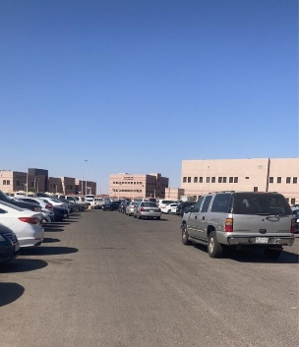
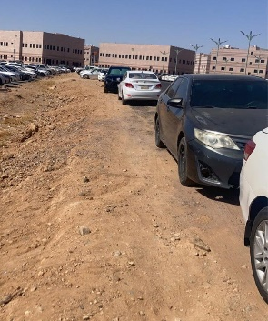
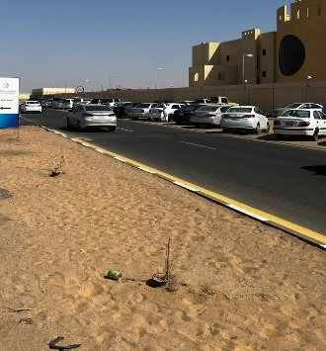
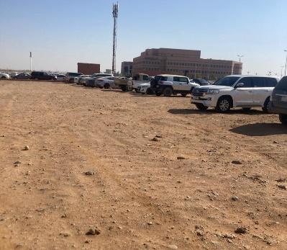

Figures 1. Some pictures contains visual distortion.

1.2.2 The 8:00 AM Congestion
The 8:00 AM congestion is a noticeable issue, characterized by significant overcrowding during this time. This results in disorganized student parking and a high level of chaos in the parking areas.

1.2.3 Staff and Faculty Members
Issues in the parking areas designated for staff and faculty members are evident, with many violations occurring in these spaces. This can lead to frustration and discomfort for employees when they are unable to find an available parking spot, forcing them to resort to violations or improper parking.

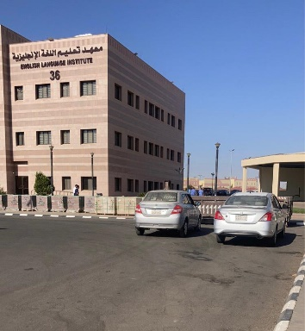
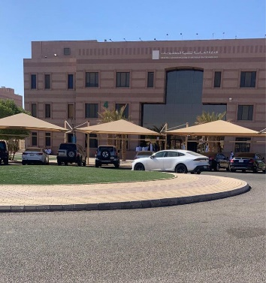
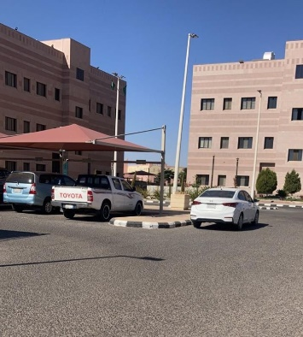

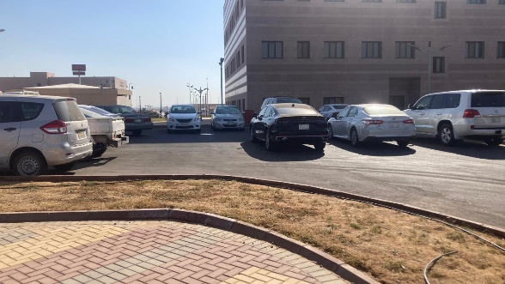

Figures 2. Wrong Parking in the staff and faculty members areas.
1.3 Objectives
Our primary objective is to ensure that the University of Tabuk offers a healthy and conducive environment for all its members. This study aims to minimize traffic congestion at the University of Tabuk by collecting data on traffic congestion at the university campus so that we can analyze the patterns to indicate the severity of the congestion and when it frequently occurs by leveraging data analysis and the tools and techniques acquired through our industrial engineering curriculum, solutions such as peak-hour restrictions to limit entry through certain gates, designated loading zones for rideshare pickups and drop-offs to prevent congestion in parking areas, flexible class scheduling can help also in minimizing peak-hour congestion, traffic calming measures by installing speed bumps, traffic islands to slow down traffic and reduce the likelihood of accident or congestion.
Analyzing the parking lots at the university campus is a fundamental component of traffic congestion analysis it can provide valuable insight into capacity, utilization, accessibility, and opportunities for improvement. Providing solutions for the parking lots such as allowing students and staff to park on campus on designated days only based on their classes or work schedule, and enforce of parking regulations consistently to deter illegal parking and encourage compliance with designated parking areas. Drawing parking lot lines to optimize capacity, easy access can contribute to minimizing traffic congestion, improving the efficiency of transportation systems, and prevent students from illegal parking at the campus.
By applying the tools of data analysis, we seek to enhance the transportation services available to students, faculty, and staff. We believe that improving these services will positively impact the academic experience, enabling students to excel in their studies at the university.

2 Literature Review
2.1 Definition of traffic congestion
According to Calderdale Council (2015), traffic congestion is an inherently difficult concept to define as it has both physical and relative dimensions. Traffic congestion can be defined in various ways depending on the context, parameters, and metrics used by different studies and institutions.
The definition of traffic congestion can be categorized into demand-related, delay-related, and cost-related. Demand can represent the cause and on the other hand, the delay and the cost represent the effect.
However, because the exact parameters and thresholds for what constitutes “congestion” can vary, there is no single, universally agreed-upon definition used across all studies and contexts.

TABLE 1. The three dimensions of defining traffic congestion. [11]
Definition | Author | Dimension
Congestion occurs when traffic demand approaches and exceeds highway capacity | Vaziri (2002) [12] | Demand-related
Congestion in transportation occurs when the occupancy of spaces (roadways, sidewalks, transit lines and terminals) by vehicles or people reaches unacceptable levels of discomfort and delay | Falcocchio and Levinson (2015) [13] | Delay-related
Congestion may be regarded as the point at which an additional road user joins the traffic flow and affects the marginal cost in such a way that the marginal social cost of road use exceeds the marginal private cost of road use at the ‘optimal’ level of congestion | Naudé and Tsolakis (2005)  [14] | Cost-related

2.2 Parking Search Caused Congestion:
Several studies have discussed the impact of searching for parking on traffic congestion, and some have proposed innovative solutions. For example, [27] the American University of Beirut examined the experiences of five American universities and concluded that university transport services do not necessarily rely on the existence of an organized public transport system. The study emphasized the importance of designing a campus transport service tailored to the needs of the target population, highlighting that reducing the number of parking spaces or imposing fees on them can significantly decrease the incentive to drive, thereby alleviating traffic congestion.

2.3 Previous Solutions and Studies
Many research studies have attempted to provide useful solutions for traffic congestion problems at universities, and some have focused on solutions based on sustainable transportation.
King Abdulaziz University [17] several solutions were proposed. First, coordinating class schedules to distribute them evenly across different days of the week can help reduce traffic density during peak hours. Second, expanding high-density gates and adjusting the gate edges can improve vehicle movement. Additionally, opening new lanes for right-turning vehicles can alleviate congestion and facilitate smoother entry. Lastly, establishing a traffic monitoring room equipped with modern devices will enable the monitoring of traffic at gates, roads, and parking areas, allowing for appropriate interventions to resolve traffic crises.
Kent State University [18] several measures are proposed. Increasing road capacity by building new roads and expanding existing ones, though expensive and time-consuming, effectively improves traffic flow. Utilizing traffic modeling software to analyze and predict congestion areas allows for informed decision-making. Additionally, improving intersection management by adding service roads can further enhance traffic flow.

2.4 Study of Parking Problem on University Campus
Beijing University of Aeronautics and Astronautics [20], This research paper discusses the parking problem on university campuses, using the Beijing University of Aeronautics and Astronautics as a case study. The increase in the number of university employees living off-campus and owning private cars has led to a shortage of parking capacity on campus. On-street parking has become common due to the shortage of parking supply, Leading to traffic congestion and safety concerns. The study surveyed and analyzed the inflow and outflow of vehicles, the location and use of parking lots, and the drivers’ parking behavior. The average parking duration and use turnovers of parking lots were computed from the survey data. The research highlights the need for better management of parking on university campuses and suggests solutions for improving the campus parking system. The research suggests implementing better management strategies for parking on university campuses, such as increasing the number of parking spaces, regulating on-street parking, and implementing parking fees and permits to encourage turnover of parking spaces.

2.5 Parking fees
An average American household travels annually about 20,000 miles on roads and spends about 15% of its income on road transportation.1 In 2011, congestion in the US caused around 5.5 billion hours of travel delay and 2.9 billion gallons of extra fuel consumption with a total cost of $121 billion [21]. [22], is that the technology needed to charge for parking is much simpler than that needed to charge for driving in congested traffic.

2.6 Sustainability
Kent State University [19] This research paper examines the level of sustainable transportation, specifically walking and bicycling, on a large university campus in the US Midwest. The paper measures the current level of walking and bicycling around the campus, surveys students about their transportation habits and attitudes, and inventories the campus infrastructure. The findings show that there is a low level of sustainable transportation among students, particularly bicycling. Reasons for this include time and convenience factors, as well as limited bicycle access. The paper suggests that existing infrastructure discourages sustainable transportation activity on campus. The study has implications for other campus communities and suggests that understanding the impediments to walking and bicycling can help universities design more attractive and useful facilities.
King Saud University [8] with some focusing on sustainable transportation. Proposed solutions include improving campus signage to provide clear directional signs, aiding students, staff, and visitors in reaching their destinations easily and safely, thereby reducing congestion and enhancing the effective use of roads and pathways. Additionally, adopting sustainable policies to reduce the demand for private car trips, implementing car-sharing programs, and encouraging the use of alternative transportation methods are crucial. Encouraging environmentally friendly transportation by increasing reliance on public transportation, providing shuttle bus services within the campus and between residential areas and the university, and promoting walking through the creation of green spaces and recreational areas to enhance the walking experience are also important measures.
2.7 Tree Planting
Soil Volume and Planting Dimensions
Studies by Penn State University emphasize the critical role of soil volume in supporting tree health. According to their recommendations, planting pits for trees in sidewalks and roads should measure no less than 1.5 meters by 1.5 meters, with a depth of **0.9 meters. They further stress that "bigger is better" to accommodate the growth of larger trees and ensure their long-term health in construction-damaged soils [24].
Spacing and Tree Placement
Urban forestry experts also underline the importance of adequate spacing between trees. Recommendations from Utah State University suggest a distance of 5 to 7 meters between trees planted in sidewalks with a width of 3 meters. This spacing allows sufficient room for root expansion and minimizes the risk of interference with surrounding infrastructure, such as pavements and utilities [25].
Parking Lot Layout Considerations
The layout and dimensions of parking spaces play a pivotal role in integrating tree planting effectively. According to technical guidelines on car park design, the standard dimensions of parking spaces vary geographically:
- European Union and Switzerland: 5 m long by 2.50 m wide.
United Kingdom: 4.80 m long by 2.40 m wide.
Canada: 5.20 m long by 2.60 m wide.
United States: 18 ft by 96 inches (5.48 m by 2.44 m).
These variations necessitate tailoring planting designs to accommodate regional standards. For example, wider parking spaces in Canada allow for more flexibility in tree placement, while narrower spaces in the UK require more strategic planning to prevent interference with vehicle operations [26].

3. Methodology
Implementation of data analysis and industrial engineering tools can facilitate a deeper understanding of congestion dynamics and inform evidence-based decision-making. By optimizing traffic flow using industrial engineering techniques, universities can improve transportation efficiency, reduce congestion-related stress for the community, and enhance overall campus accessibility and sustainability.
We collected data on student attendance in lecture halls after requesting it from the university to ensure the accuracy of the number of students present at different times throughout the week. As for the number of parking spaces, some were calculated manually, such as those for employees and faculty members. For student parking spaces, they were estimated by calculating the parking area while taking into account curbing and landscaping. Several criteria were used to ensure a sustainable and aesthetically pleasing design suitable for the university.
Vehicle Lanes:
The width of vehicle lanes typically ranges from 6 to 9 meters, depending on the direction and flow of traffic.
Pedestrian Sidewalks:
Sidewalks for pedestrians are generally allocated a width of 2 to 3 meters.
Parking Space Dimensions:
A standard parking space measures approximately 5 to 5.5 meters in length and 2.5 meters in width, resulting in an area of 12.5 square meters per parking spot.
Example Calculation:
Given a total area of 1,000 square meters, the following allocations are made:
300 square meters for vehicle lanes.
50 square meters for pedestrian sidewalks.
This leaves 650 square meters available for parking spaces.
To determine the number of parking spaces:
$$Number of parking spaces=\frac{Total parking area}{Area per parking spot}= \frac{650}{12.5}=52 spaces$$
This calculation demonstrates how land allocation impacts the number of parking spaces in a given area. [29] [30]
We used the R program for analysis due to the large volume of student attendance data, which was then exported to Excel and Power BI for further processing.
The parking areas were divided into six zones, with multiple colleges grouped into one zone due to their proximity and the overlapping parking patterns of students in these areas. As shown in the university map, the distribution of parking spaces is clearly marked, with each zone represented in a different color.
Zone A Includes: Engineering + Pharmacy + Science (Female) + IT (Male) + Buisness ( Male)+ Building 13
Zone B includes: Business (Female) + Design ( Female)
Zone C Includes: Medicine (Male, Female) + College of Applied Science (Male, Female) + Health Science (Female, male) + Nursing (Male and Female)
Zone D Includes: College of Education and Arts (Female)
Zone E Includes: Sharia and Law (Male) + College of Education and Arts (Male)
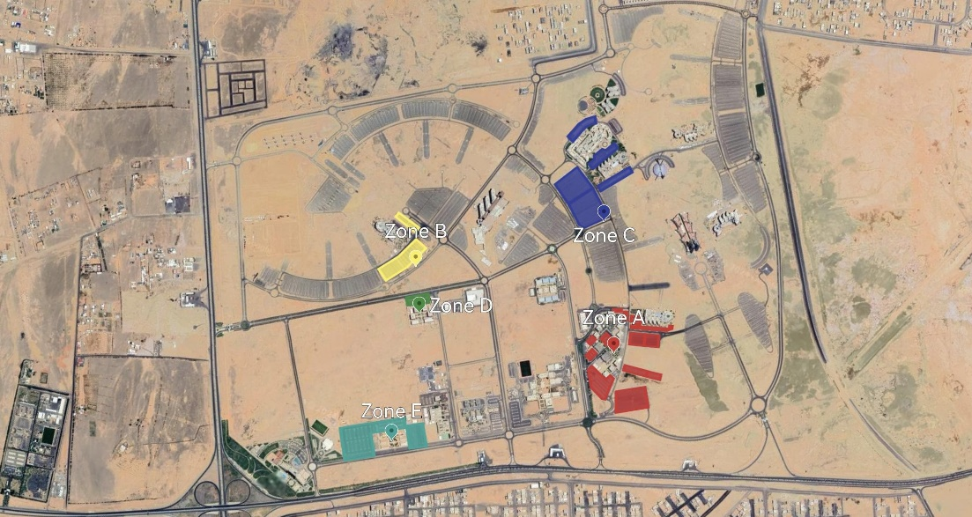

Figures 3. University map.
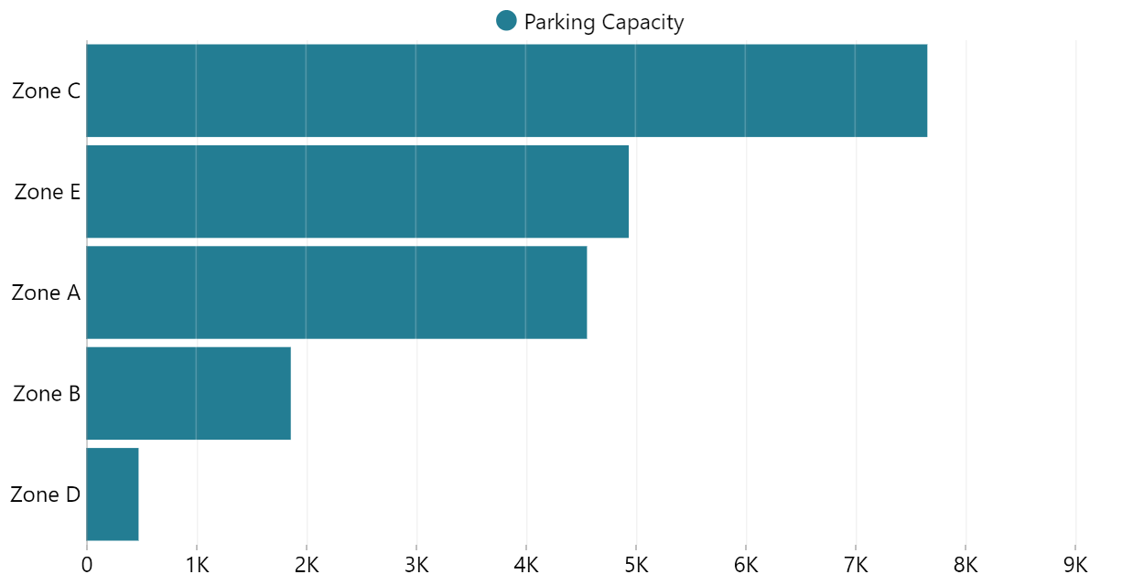

Figures 4. Parking Capacity.
In calculating the percentage of students coming to the university in their own cars, we relied on [28] survey that the number of students who drive their own cars is 88.5% of the total number of students who come by car, including those who arrive with their parents or friends.

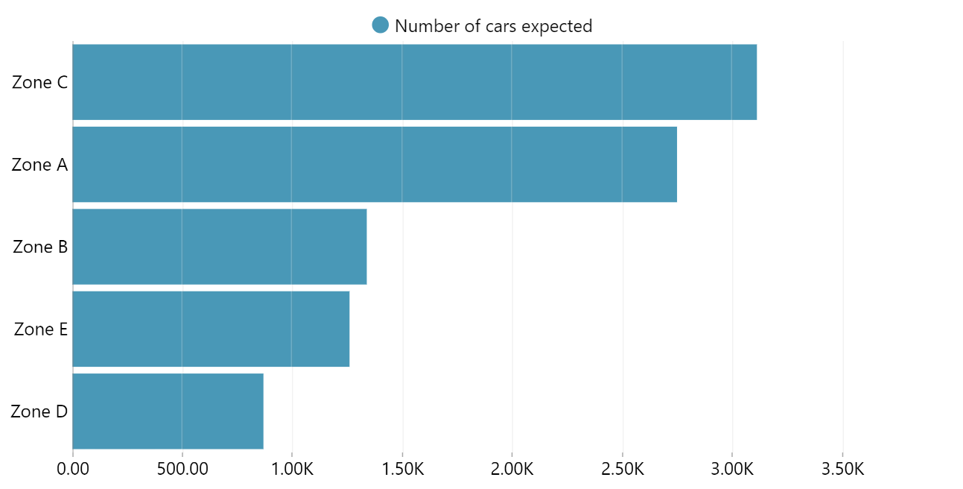

Figures 5. Number of cars expected.
As mentioned in our objectives, we aim to establish parking areas that reflect the university's reputation in terms of aesthetics, design, and alignment with sustainability goals. This involves curbing, planning, and landscaping the parking spaces. Before analyzing the data, we considered these aspects. For example, after determining the total area of the parking spaces in Zone A, we accounted for their design and landscaping before calculating the number of parking spots.

4. Data Analysis and Results
As mentioned in the methodology, we used the R software to analyze and merge the data first. Then, we exported the file to review and modify it in Excel.
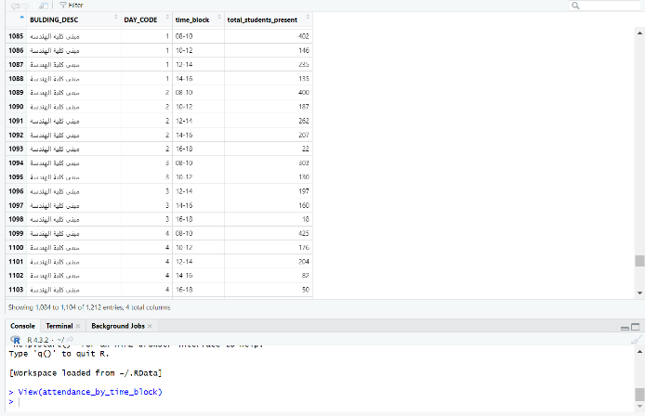
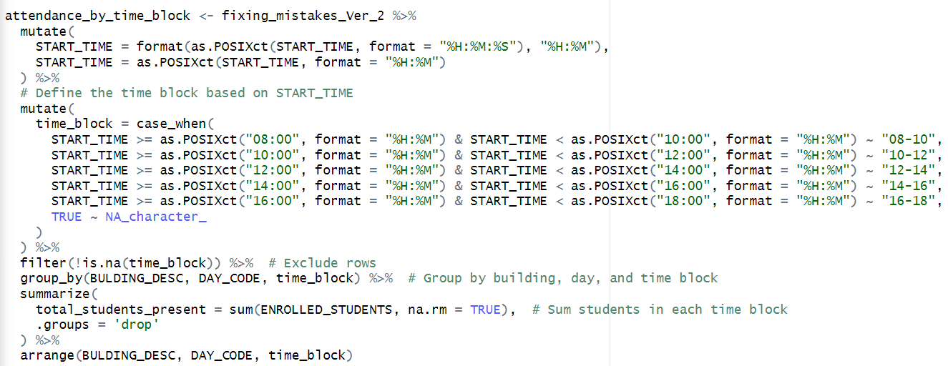

Figures 6. The code and the results in R.
All parking zones were analyzed in relation to the number of students, and the results were as follows:

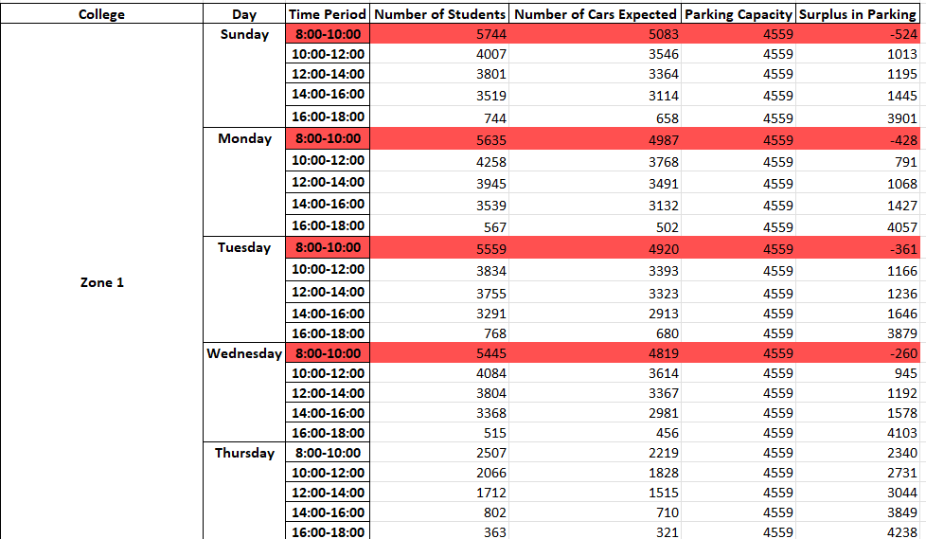

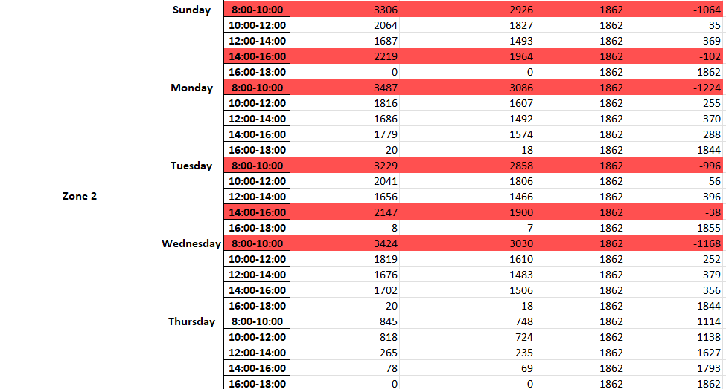

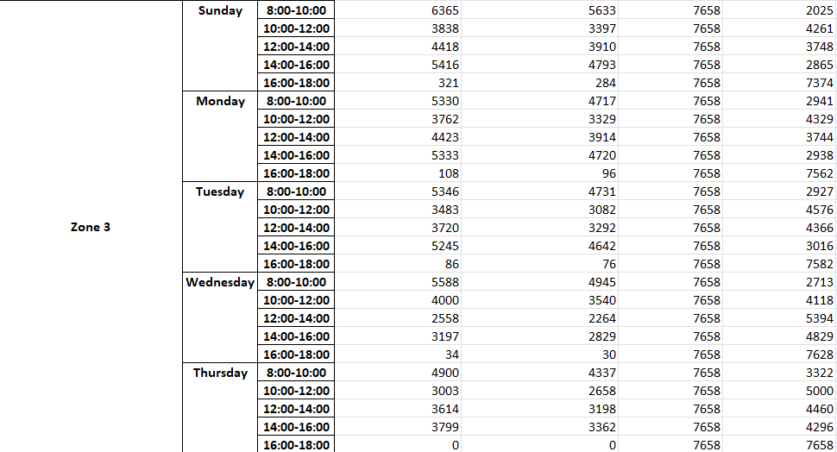

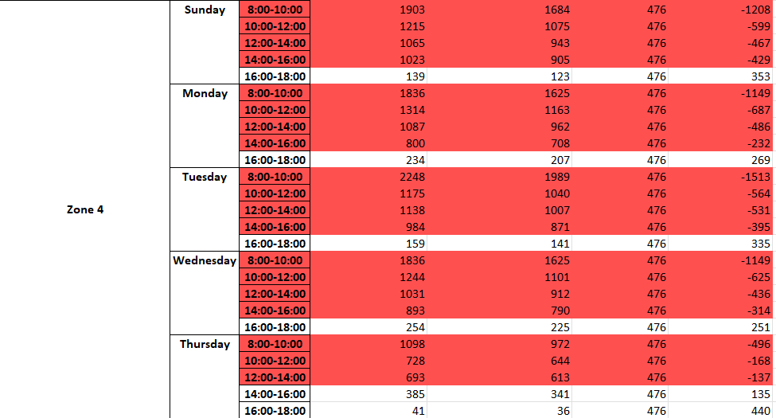

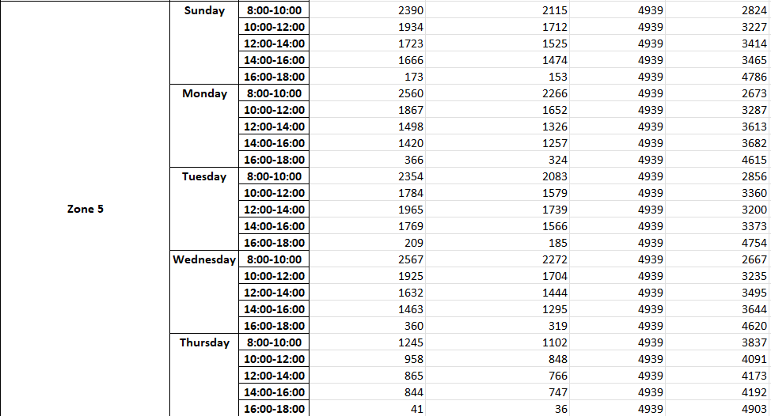

Figures 7. Results of our students parking analysis.
Zone A: Congestion was only observed at 8:00 AM on weekdays. This aligns with our firsthand observations as students in this zone, where heavy traffic leads to chaotic and unorganized parking, creating an unpleasant visual impact.
Other zones: No significant issues were found regarding parking availability.
To investigate further whether the occupancy rate during the 8-10 AM period is significantly higher than that during other periods, a Welch Two-Sample t-test was conducted. This test was selected because the data might not have equal variances across the groups. The analysis compared the occupancy percentage during the 8-10 AM period and the other time periods (10-12, 12-2, etc.) across all five parking areas..
Hypothesis Testing:
Null Hypothesis (H₀): There is no significant difference in the occupancy rates between the 8-10 AM period and other periods.
Alternative Hypothesis (H₁): The occupancy rate during the 8-10 AM period is significantly higher than the other periods.

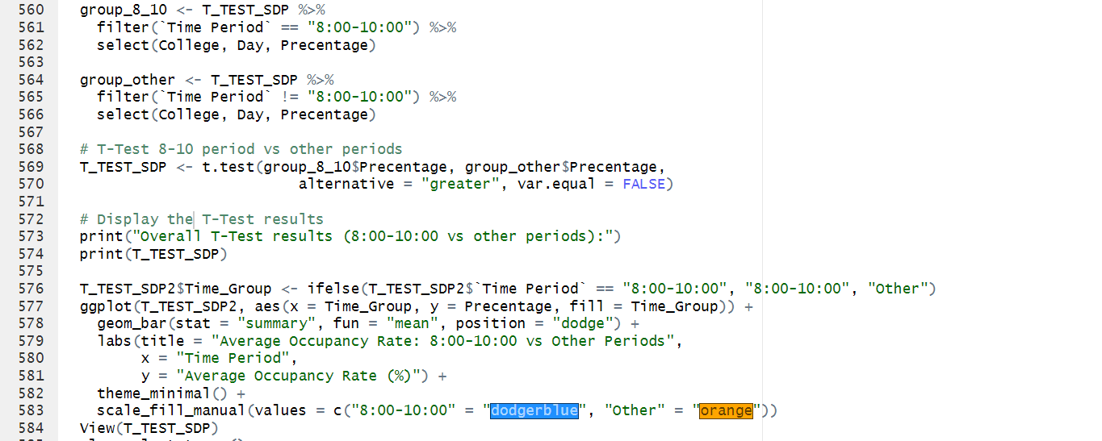

Figures 8. The code used for the T-TEST.

The results of the Welch Two-Sample t-test are as follows:
t = 3.0452
df = 27.523
p-value = 0.002539
95% Confidence Interval: [31.64939, Inf]
Mean of 8-10 AM period: 133.53%
Mean of other periods: 61.77%
Given the p-value of 0.002539, which is less than the typical significance level of 0.05, we reject the null hypothesis. This indicates that the occupancy rate during the 8-10 AM period is statistically significantly higher than during the other time periods.

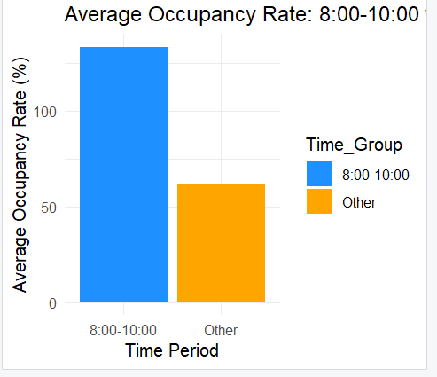

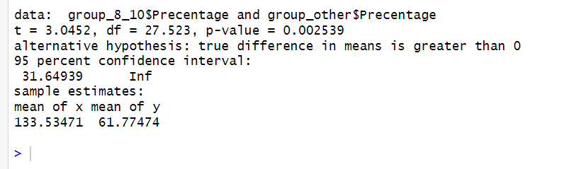

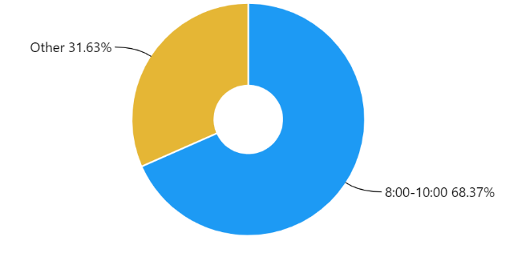

Figures 9. Results of The T-TEST analysis.
The average occupancy rate during the 8-10 AM period is approximately 133.53%, which is significantly higher than the average occupancy rate during the other periods (approximately 61.77%). The 95% confidence interval indicates that the true difference in means is likely to be at least 31.64%, which further supports the conclusion that the 8-10 AM period represents a critical peak time for parking demand.
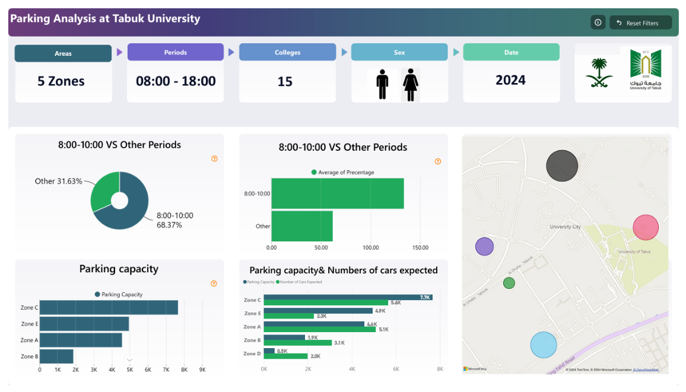

Figures 10. Final analysis for The students parking zones.

As for faculty and staff parking, the analysis revealed several problems, which were also evident through direct observation.
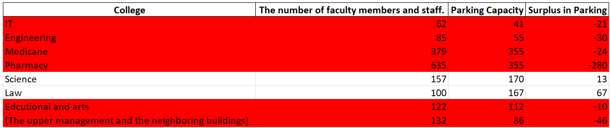

Figures 11. Results of our Faculty members and staff parking analysis.

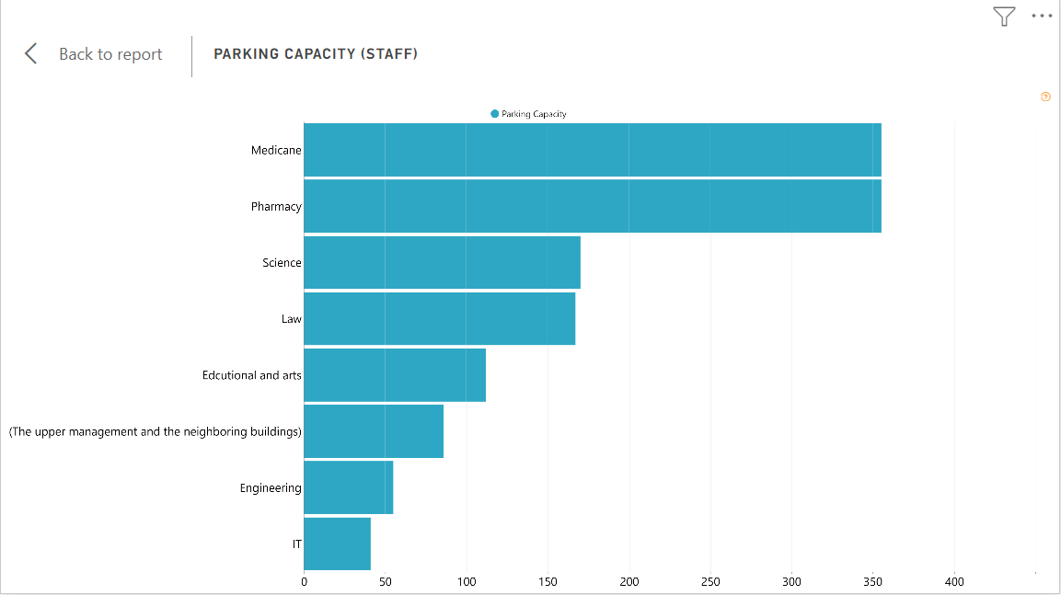

Figures 12. Parking capacity (Staff).

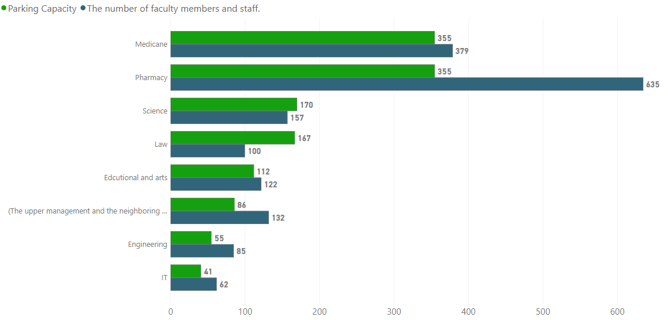

Figures 13. Surplus of parking capacity in the staff parking.

5. Recommendations
After analyzing the data and identifying the underlying problem with parking at the university, which has caused traffic congestion and an unappealing appearance, we propose several solutions to create organized and visually appealing parking areas that reflect the standards of the University of Tabuk.
These suggestions include:
Better Scheduling of Lectures: Adjusting lecture times to move away from the concept that university students must begin their day at 8:00 AM. University students are generally flexible and can attend classes starting later in the morning. This adjustment would help the university organize parking more effectively, as the peak issue lies within the 8:00–10:00 AM time frame.
Implementing Curbs in Parking Areas: Adding curbs in the parking areas to prevent visual clutter caused by unorganized spaces and ensuring proper parking alignment.
Designating Pedestrian Walkways: Creating designated pedestrian pathways for individuals after they exit their vehicles, so they don't have to walk between parked cars, enhancing safety and organization.
Supporting Sustainability: Incorporating greenery by planting trees in parking areas, promoting a more sustainable and pleasant environment.
Introducing Premium Parking Spaces: Allocating certain convenient and easily accessible parking spaces near buildings as premium parking areas. However, access to these spaces would require students to achieve a specific GPA or higher. This system would not only provide economic benefits for students but also serve as a motivational tool to improve academic performance.
Monitor Utilization Regularly: Conduct periodic reviews of staff parking usage to evaluate the need for expansion or redistribution of spaces.
Expand Parking Capacity for Staff: If feasible, create additional parking spaces designated exclusively for staff to address shortages.

6. Conclusion
The project provided an analysis highlighting clear issues for the university regarding lecture scheduling, parking organization, and layout planning, as well as addressing the current visual distortion. Our recommendations emphasized covering all these aspects, which, if implemented, would result in more organized and visually appealing parking spaces. This, in turn, would lead to reduced traffic congestion and offer a significant partial solution to the broader traffic problem.

REFERENCES
1- Bull, Alberto. "Traffic congestion: The problem and how to deal with it." (2003).

2- Isiaka, Abdulazeez, and Ho Chin Siong. "Developing sustainable index for university campus." EASTS international symposium on sustainable transportation incorporating Malaysian universities transport research forum conference. 2008.

3- Norzalwi, Norsyuhadah, and Amiruddin Ismail. "Public approach towards sustainable transportation in UKM's campus." Australian Journal of Basic and Applied Sciences 5.5 (2011): 1332-1337.

4- Shuhana Shamsuddin, Ahmad Bashri Sulaiman, Hasanuddin Lamit, Rozeyta Omar, Norsiah Abd. Aziz, Masliyana Md. Noor. (2007). Kriteria Reka Bentuk Persekitaran Kampus Yang Kondusif Bagi Institusi Pengajian Tinggi Di Malaysia. University Teknologi Malaysia.

5- Taylor, Brian D. "Rethinking traffic congestion." Access Magazine 1.21 (2002): 8-16.

6- Rahman, Mamun Muntasir, Glen Martin D'Este, and Jonathan Bunker. "Is there a future for non-motorized public transport in Asia?." Proceedings of the Eastern Asia Society for Transportation Studies Vol. 7 (The 8th International Conference of Eastern Asia Society for Transportation Studies, 2009). Eastern Asia Society for Transportation Studies, 2009.

7- Dehghanmongabadi, Abolfazl, and Şebnem Hoşkara. "Challenges of promoting sustainable mobility on university campuses: The case of Eastern Mediterranean University." Sustainability 10.12 (2018): 4842.

8-Al-Mosaind, Musaad. "Traffic Conditions in Emerging University Campuses: King Saud University, Riyadh, Saudi Arabia." Journal of Sustainable Development 7.6 (2014): 204.

9- World Commission on Environment and Development, and Gro Harlem Brundtland. Opening Address by Gro Harlem Brundtland... on the Occasion of the Launch of the Report" Our Common Future", London, England, 27 April 1987. World Commission on Environment and Development, 1987.
10- ​ United Nations (UN). (2012). Report of the United Nations conference on sustainable development (A/CONF.216/16). New York: United Nations

11- Nguyen-Phuoc, Duy Q., et al. "Traffic congestion relief associated with public transport: state-of-the-art." Public Transport 12.2 (2020): 455-481.

12- Vaziri M (2002) Development of highway congestion index with fuzzy set models. Transp Res Rec 1802:16–22

13-Falcocchio JC, Levinson HS (2015) Road traffic congestion: a concise guide, Roger P. Roess. New York University Polytechnic School of Engineering, New York

14- Naudé C, Tsolakis D (2005) Defining transport congestion. ARRB contract report no. VC71854.
Melbourne

15- parking [Arnott, Richard, and Eren Inci. "An integrated model of downtown parking and traffic congestion." Journal of Urban Economics 60.3 (2006): 418-442.]

16-Ye, Liang, Ying Hui, and Dongyuan Yang. "Road traffic congestion measurement considering impacts on travelers." Journal of Modern Transportation 21 (2013): 28-39.

17- El-Quliti, Said Ali, and Seraj Yousef Abed. "An Approach to Analyze and Solve Traffic Problems in Universities: Model of King Abdulaziz University، Kingdom of Saudi Arabia." Arab Gulf Journal of Scientific Research 31.4 (2013): 223-237.

18-Kaplan, David, and Thomas Clapper. "Traffic Congestion on a university campus." Society for College and University Planning (2007): 28-39.

19- Kaplan, David H. "Transportation sustainability on a university campus." International Journal of Sustainability in Higher Education 16.2 (2015): 173-186.

20- Shang, Huayan, L. I. N. Wenji, and Haijun Huang. "Empirical study of parking problem on university campus." Journal of Transportation Systems Engineering and Information Technology 7.2 (2007): 135-140.

21- Schrank, D., Eisele, B. and Lomax, T. (2012) TTI’s 2012 Urban Mobility Report Technical report Texas Transportation Institute, Texas A&M University College Station.

22- Shoup, D. (2005) The High Cost of Free Parking Planners Press, American Plan ning Association Chicago, Illinois, Washington D.C.

23- Zimmerman, Eilene (2011). CNN Money. Quoting Zia Youssef http://money.cnn.com/2011/04/29/technology/streetline/ accessed 9/4/2014

24- Penn State Extension. (n.d.). Understanding Tree Planting in Construction-Damaged Soils

25- Utah State University Extension. (n.d.). Small Trees as Street Trees?

26-Biblus. (n.d.). How to Design a Car Park: The Complete Technical Guide.
27-Aoun, Alisar, et al. "Reducing parking demand and traffic congestion at the American University of Beirut." Transport Policy 25 (2013): 52-60.
28- Rissel, Chris, Corinne Mulley, and Ding Ding. "Travel mode and physical activity at Sydney University." International journal of environmental research and public health 10.8 (2013): 3563-3577.
29- https://istitlaa.ncc.gov.sa/ar/Municipality/momra/Car/Pages/default.aspx
30- University of Houston. Campus Design Guidelines and Standards: Section 9.0 Parking Lot and Pavement Design Standards. University of Houston, n.d.

